***States, Values, and Predicates***

***CS 536: Science of Programming; Due Fri Sep 9[1]***

# Problems [50 points total]

**For details on how to submit your homework, see** [**http://cs.iit.edu/~cs536/**](http://cs.iit.edu/~cs536/) **→ Syllabus. Feel free to convert logical symbols into text as in Homework 1.**

1. **[9 = 3 * 3 points] For each of the following expressions, say whether it is legal or illegal for our programs. Assume that b and b′ are arrays of integers and other variables are integer variables[2].**
   1. **(x = y ? z : b[z]).** Legal
   2. **b[(i = 3 ? j : k+2)]** Legal
   3. **(i = 3 ? b : b′)[k]** Illegal
2. **[6 = 3 * 2 points] Explain briefly why each of the following diagrams does not show a proper memory state.**

|  |  |  |  |  |  |  |  |
| --- | --- | --- | --- | --- | --- | --- | --- |
| |  | | --- | | **12** |     b  a | |  |  |  |  |  | | --- | --- | --- | --- | --- | | **0** | **b** | **0** | **2** | **4** | |

* 1. **τ₁**

**Ans:** It is not a valid state as we cannot have two bindings for b in one state.

|  |  |  |  |
| --- | --- | --- | --- |
| |  |  |  | | --- | --- | --- | | **2+2** | **b** | **x+1** |   **x** |

* 1. **τ₂**

**Ans:** We cannot have expressions as values of state. They should be syntactic values.

* 1. 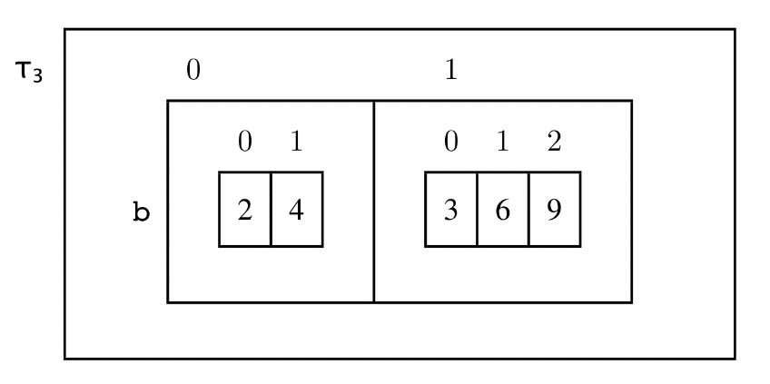

**Ans:** we dont have arrays of arrays represented in states.

1. **[9 = 3 * 3 points] For each of the states and expressions below, is the state proper for the expression? If not, why?**
   1. **State {x = 5, b = (5, 8)} and expression x+1 = b[0*y]**

**Ans:** It is not a proper state as there is no binding of y in the state for the expression.

* 1. **State {b = (5), i = 0, x = 1} and expression x > b[i]**

**Ans:** it is a proper state for expression as b is an array.

**Hint: What’s the difference between {b = 5, …} and {b = (5), … }?**

* 1. **State {w = 2, x = T, z = 12} and expression (z > w ? w : x).**

**Ans:** It is not a proper state as x should be an integer as w is an integer as in exp (B?e1:e2) e1 and e2 should have same type.

1. **[9 = 3 * 3 points] Let σ = {x = 2, y = 4, b = (11, 21, 31, 41)}.**
   1. **What is σ[x ↦ 8][x ↦ 5]?**

**Ans:** σ[x ↦ 8][x ↦ 5] = σ[x ↦ 5] = {x = 5, y = 4, b = (11, 21, 31, 41)}.

* 1. **What is σ[y ↦ 5](x)?**

**Ans:** σ[y ↦ 5]  = {x = 2, y = 5, b = (11, 21, 31, 41)}

Hence, σ[y ↦ 5](x)=2

* 1. **What is σ[b[1] ↦ 13][y ↦ σ(b[1]/2)]?**

**Ans:** σ[b[1] ↦ 13][y ↦ σ(b[1]/2)]

= σ[b ↦  δ ][y ↦ σ(b[1]/2)] where δ = σ(b)[σ(1) ↦ 13]

let σ[b ↦  δ ]= σ`

Then σ` = {x = 2, y = 4, b=(11,13,31,41)}.

= σ[b ↦  δ ][y ↦ σ(b[1]/2)] where δ = σ(b)[σ(1) ↦ 13]

= σ`[y ↦ σ(b[1]/2)]

= σ`[y ↦ σ(13/2)] as b[1]=13 in σ`

= σ`[y ↦ σ(6)] as 13 and 2 are integers hence ignore remainder

= σ`[y ↦  6] as 6 is constant

= σ`[y ↦ 6] = {x = 2, y = 6, b=(11,13,31,41)}.

1. **[9 = 3 * 3 points] Each of the following satisfaction claims is correct. (Honest.) Show this by giving a witness value and writing the updated state ⊨ predicate we need to verify. If you need to, assume that if i is out of range, then b[i] yields 0. Assume all values come from** **ℤ.**
   1. **{x = 5, y = 2} ⊨ ∃x . x < y**

**Ans:** for State having σ {x = 5, y = 2} ⊨ ∃x . x < y

σ –x = σ {y = 2} ⊨ ∃x . x < y

(σ –x)[x↦0] = σ {x=0,y = 2} ⊨ ∃x . x < y

In this state the predicate is true

* 1. **{b = (3, 1, 0), k = T} ⊨ ∃ 0 ≤ i < 3 . b[i] ≤ 0**

**Ans :** let σ = {b = (3, 1, 0), k = T} ⊨ ∃ 0 ≤ i < 3 . b[i] ≤ 0

σ [i ↦ 2] ={b = (3, 1, 0), k = T,i=2} ⊨ ∃ 0 ≤ i < 3 . b[i] ≤ 0

In this state It holds true

* 1. **{b = (1, 3, 4, 6)} ⊨ ∃i . 0 ≤ i ≤ 2 → b[i] < 0**

**Ans:** Let σ = {b = (1, 3, 4, 6)} ⊨ ∃i . 0 ≤ i ≤ 2 → b[i] < 0

σ [i ↦ -1] ={b = (1, 3, 4, 6),i=-1} ⊨ ∃i . 0 ≤ i ≤ 2 → b[i] < 0

In this state ∃i . 0 ≤ i ≤ 2 → b[i] < 0 is of the form ∃I F → F

Which is T

1. **[4 points] Show ⊭ ∃x . ∀y . x > y by proving ∅ ⊨ ∀x . ∃y . x ≤ y. (The empty set is the empty memory state.) Don't forget to give a name to the value of x.**

**Ans:**  Let σ ⊨ ∀x . ∃y . x ≤ y

Let us change state of x to α and y to α-1 then σ [x ↦ α] [y ↦ α-1] = α ≤ α-1 where α  ∈ **ℤ** for this set of states there isn’t any value hence σ⊭ ∃x . ∀y . x > y

1. **[4 points] Give the definition of a predicate function isMax(x, b) that is true iff x appears in b and every element of b is ≤ x. For example, the state {b = (2, 5, 6)} satisfies isMax(6,b) but not isMax(4,b) or isMax(10, b). Remember, we need a definition isMax(x, b) ≡ some predicate (and predicates don't have while loops).**

**Ans:** assume that if i is out of range, then b[i] yields 0 and i∈ **ℤ**

isMax(x, b) ≡ 0 ≤ i **<** size(b) ∧b[i]=x ∧ b[i] ≤ x

1. I've delayed the due date a couple of days, but I want people to have time to study the answers before Quiz 1, so we won't accept late homeworks.
2. As in C, in (*B* ? *e*₁ : *e*₂) we require *e*₁ and *e*₂ to have compatible types. (For us, that means the same type.)